Requirement:
============

To deploy a serverless web application which can write data into and read data from a serverless database .The application should be capable of handling user requests securely with encryption and good efficiency .
------------------------------------------------------------------------------
Solution :
**Pre-requisite
=============
1. AWS account
2. IAM role for Lambda

**Which services are used
========================

1. S3 ::
S3 bucket to host our static web content, including HTML, CSS, and JavaScript files.

2. API GATEWAY ::
to trigger Lambda functions for both GET and POST methods to interact with our DynamoDB database.

3. LAMBDA ::
in Python to handle the API Gateway requests (read and write)

4. DYNAMO DB::
to store our data - serverless

5. CLOUD FRONT ::
To ensure secure access to our web application, we'll deploy CloudFront as a content delivery network (CDN)We'll configure CloudFront to serve our S3 content securely over HTTPS, providing encryption in transit and improving the performance of our application.

**APPROACH :
=========

Step1 : Create Dynamo DB tables and Lambda function for GET and POST calls.

1.Create Dynamo DB table .
2.Create a Lambda Function for GET .

Create and attach customer IAM Role under Permissions section to this GET function.
This role will allow the GET function to read data from DynamoDB
Ensure that IAMRole should allow read and write (get and post calls) during creation.
Next,
3.Create a Lambda Function for POST .

Create and attach customer IAM Role under Permissions section to this POST function.
This role will allow the POST function to insert data from DynamoDB
Ensure that IAMRole should allow read and write (get and post calls) during creation.

Successfully inserted data into DynamoDB as below
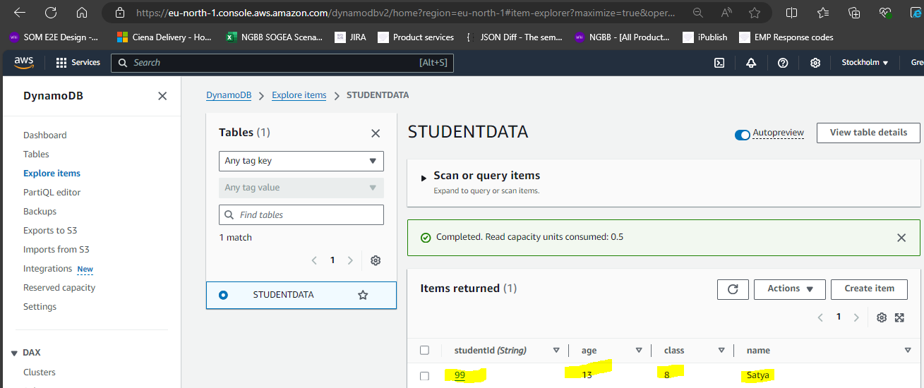

Successfully fetched data from DynamoDB as below
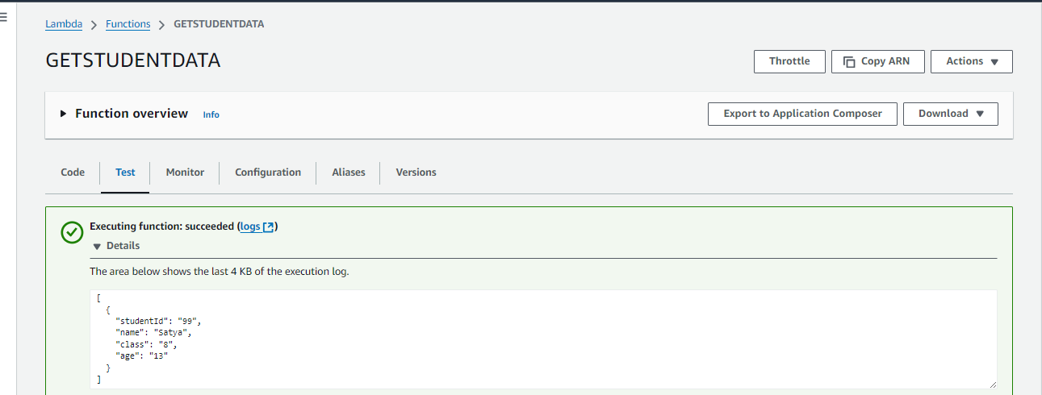

Step2: Create API Gateway to trigger Lambda functions

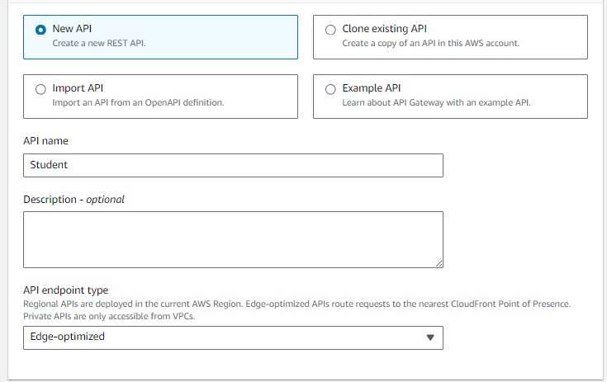
Edge Optimized allows users from around the world.
Create method for GET and POST uder this APIGW
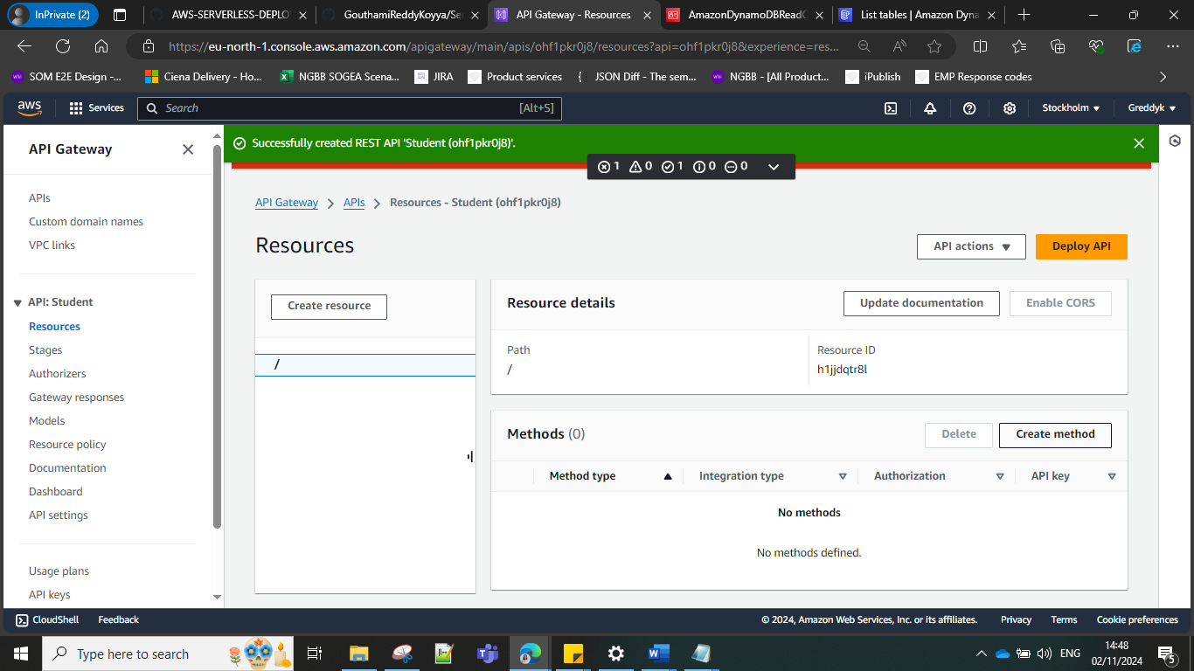

Deploy API GW – our API will need to be deployed to get a URL.
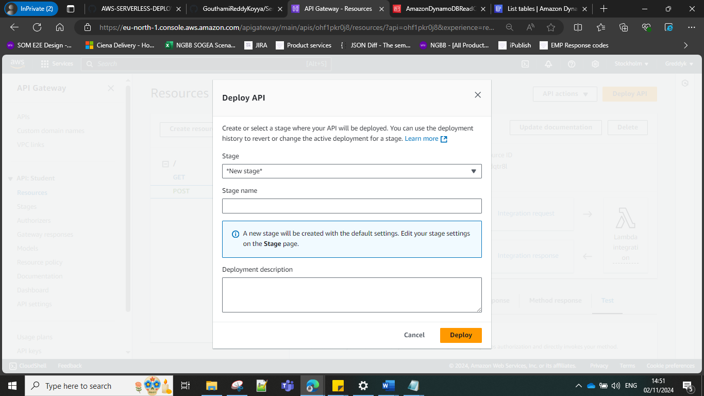
Invoke URL – this URL triggers the lambda functions GET and POST

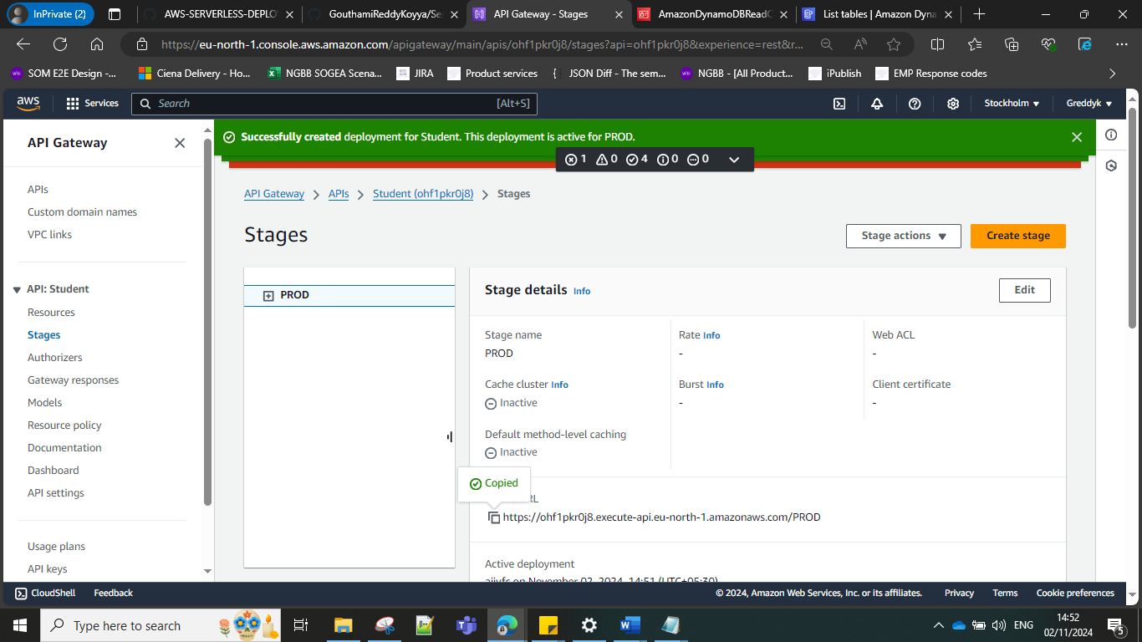

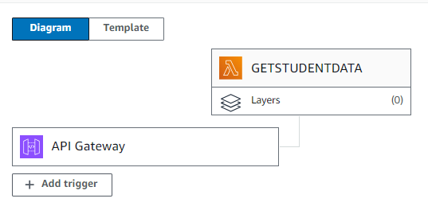

Paste the APIGW URL in script.js

ENABLE CORS for the APIGW - When you enable CORS (Cross-Origin Resource Sharing) for Amazon API Gateway (APIGW), it allows your API to be accessed by web applications running on different domains.

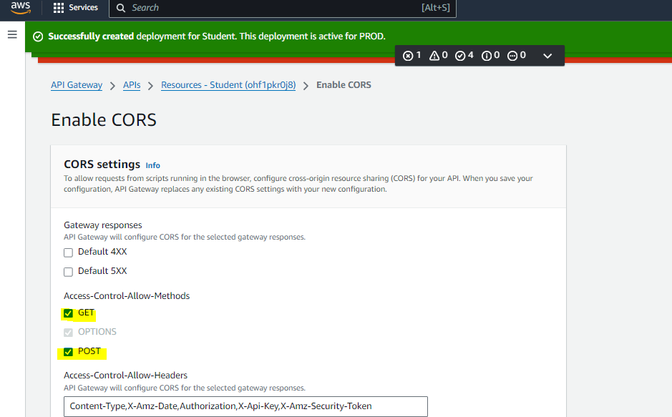

Create S3 bucket – studentbuckett
Upload files

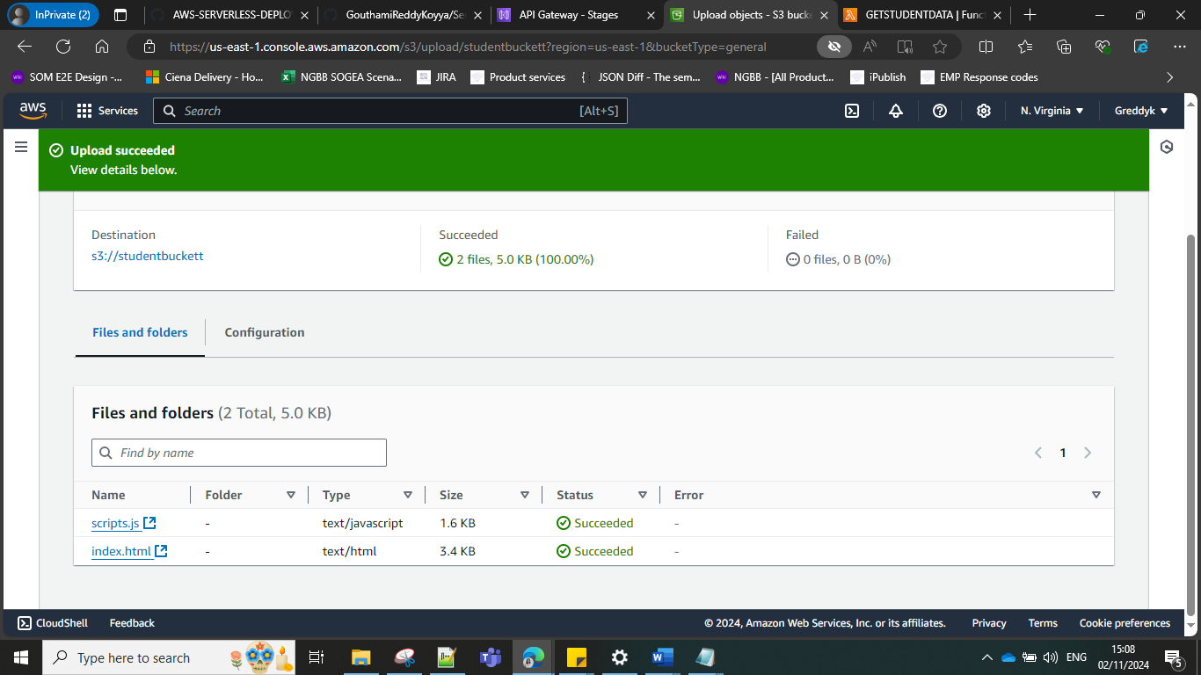

Enable Static website and give the name of html file , here it is index.html and then you have a URL created for the website.
Make the URL of bucket public else you get access denied.
Write bucket policy to allow users access to read files/objects in the bucket.otherwise 403.
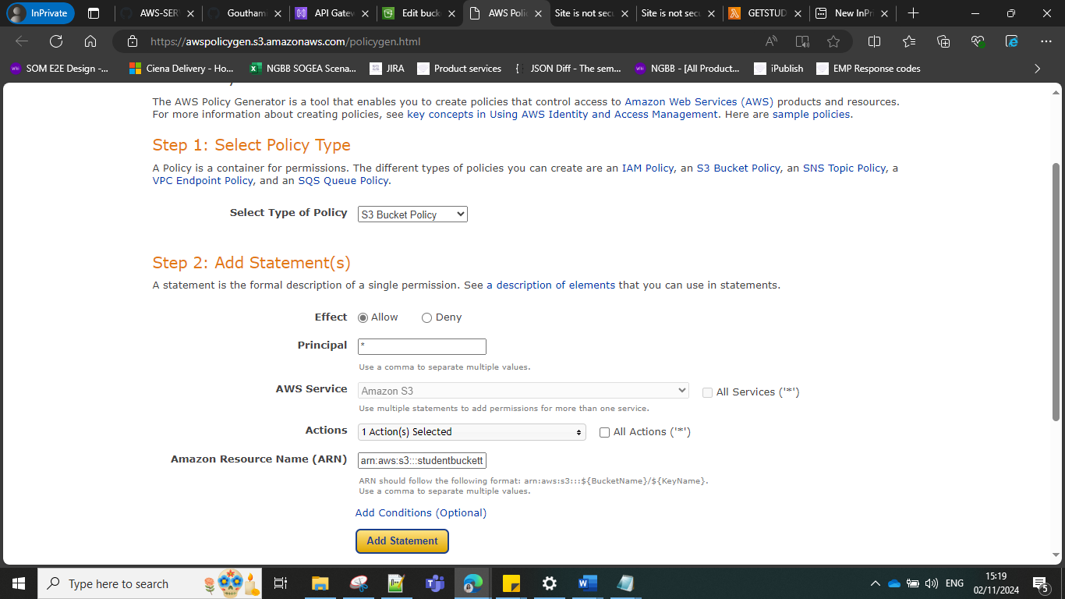

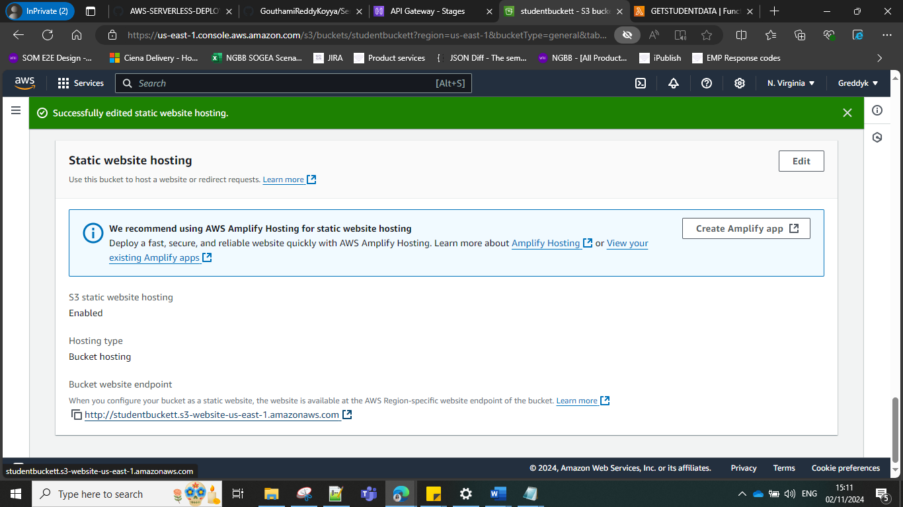
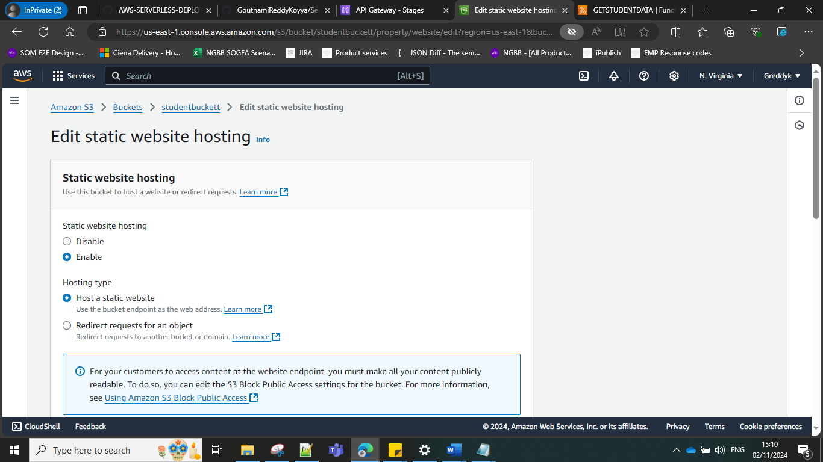
BUCKET -POLICY
{
"Version": "2012-10-17",
"Id": "Policy1730541377694",
"Statement": [
{
"Sid": "Stmt1730541002650",
"Effect": "Allow",
"Principal": "*",
"Action": "s3:GetObject",
"Resource": "arn:aws:s3:::studentbuckett/*"
}
]
}

FINALLY OUR S3 website is ready.

When clicked on View , we can view what we saved
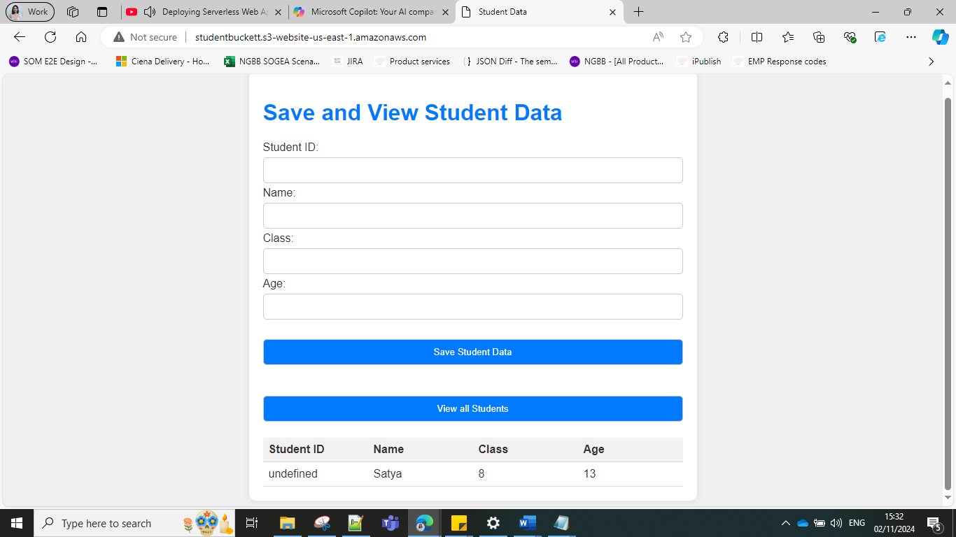

On inserting the below data
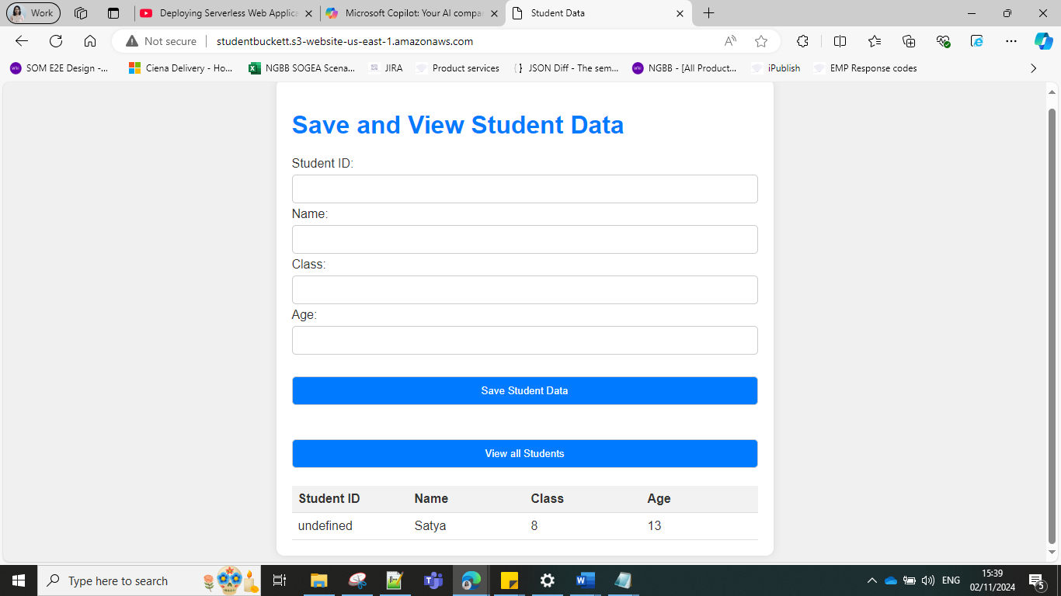

And clicking VIEW

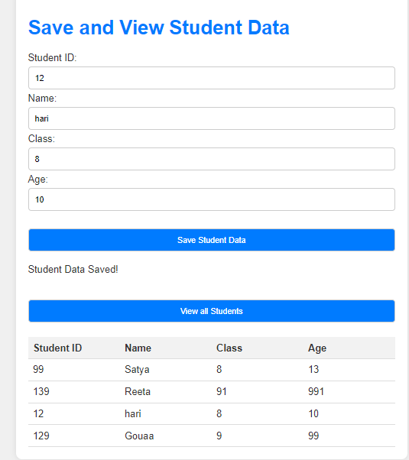

Step 3: Securing with Cloud Front

Student Data

HTTP is not secure.
Create Clouf Front.
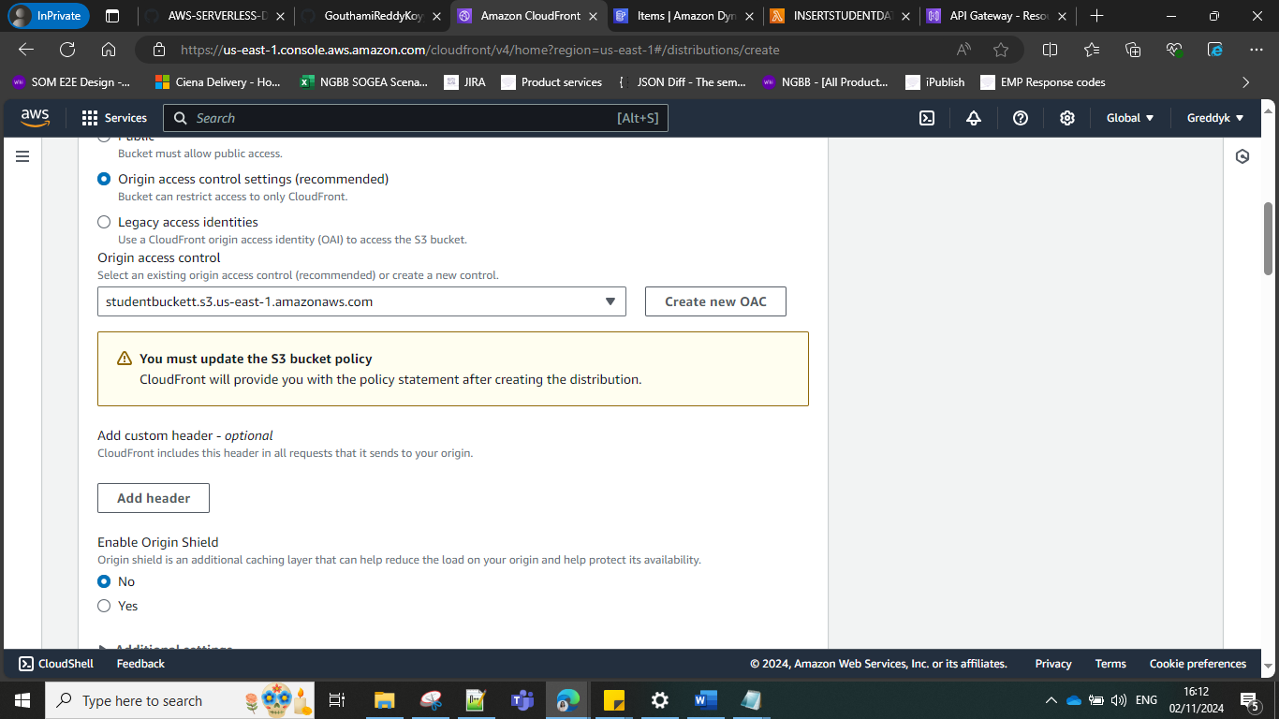

Which file to be accessed.
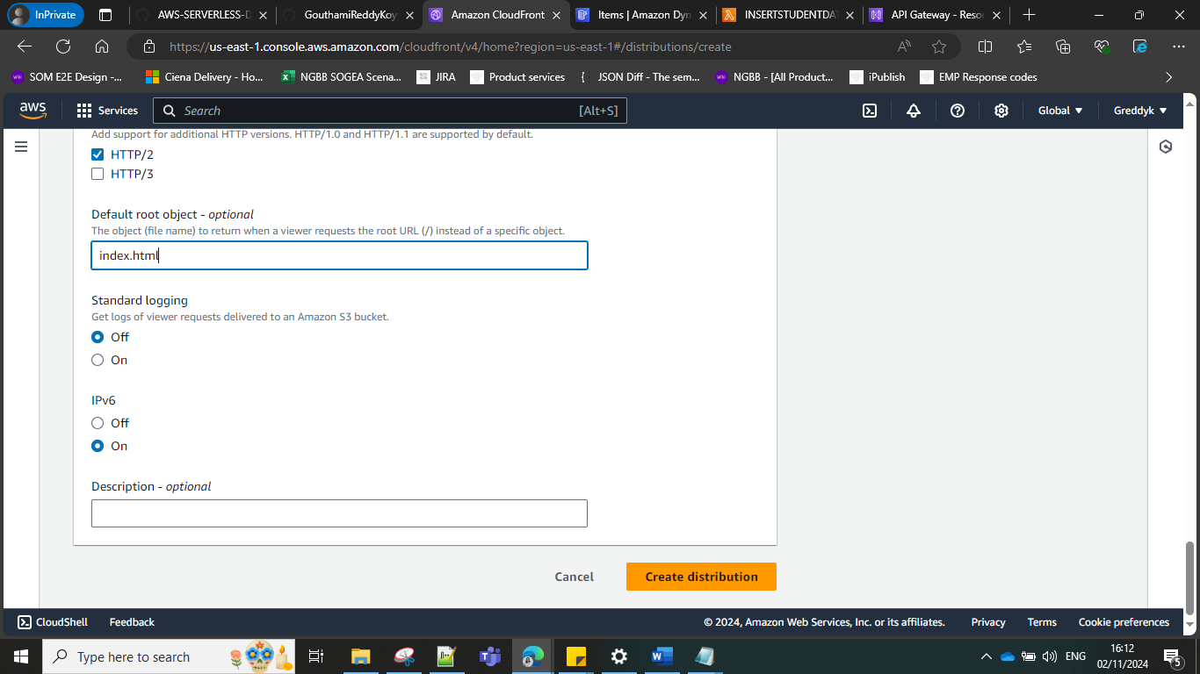

Copy policy
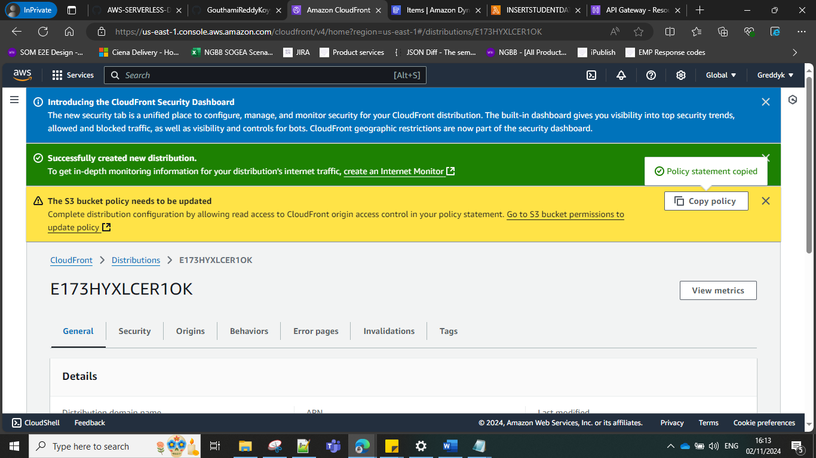

Make the bucket private
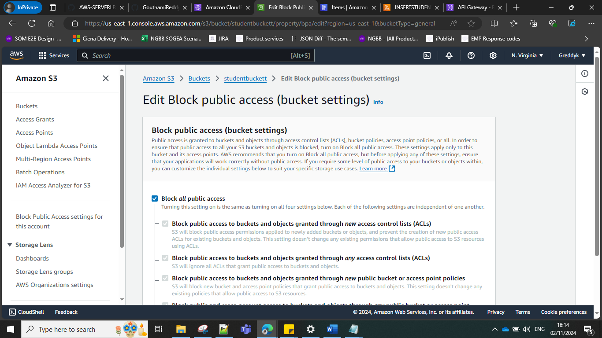

This the cloudfront
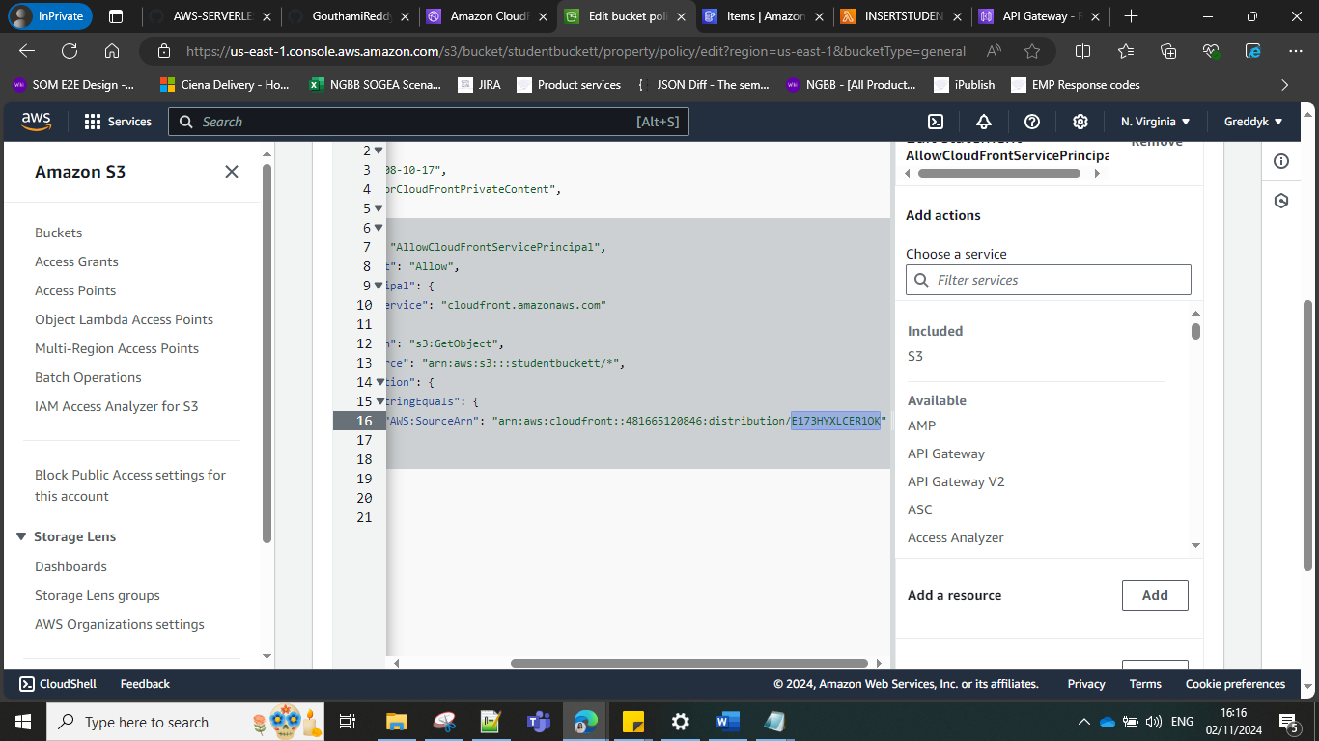

Get the URL of CloudFront from here
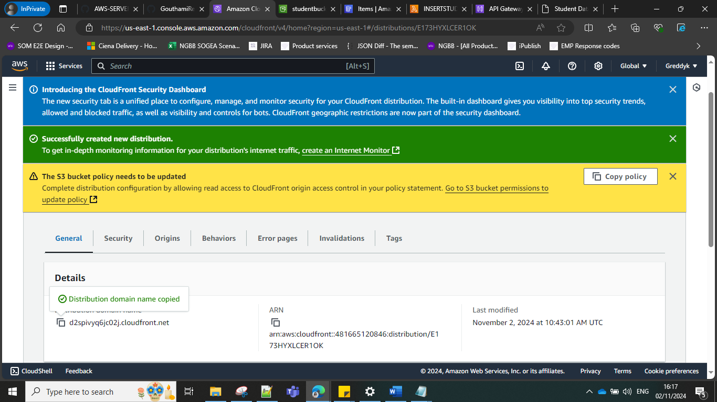

Our website
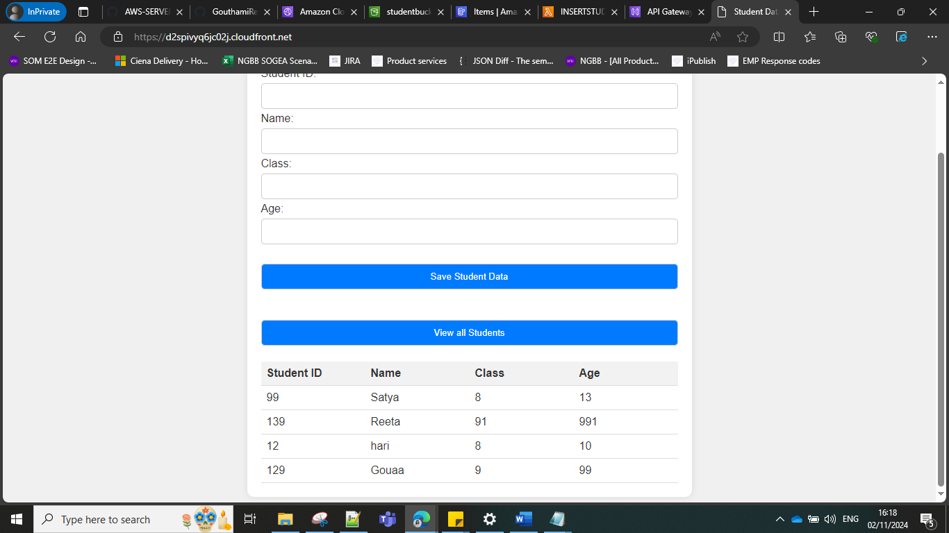

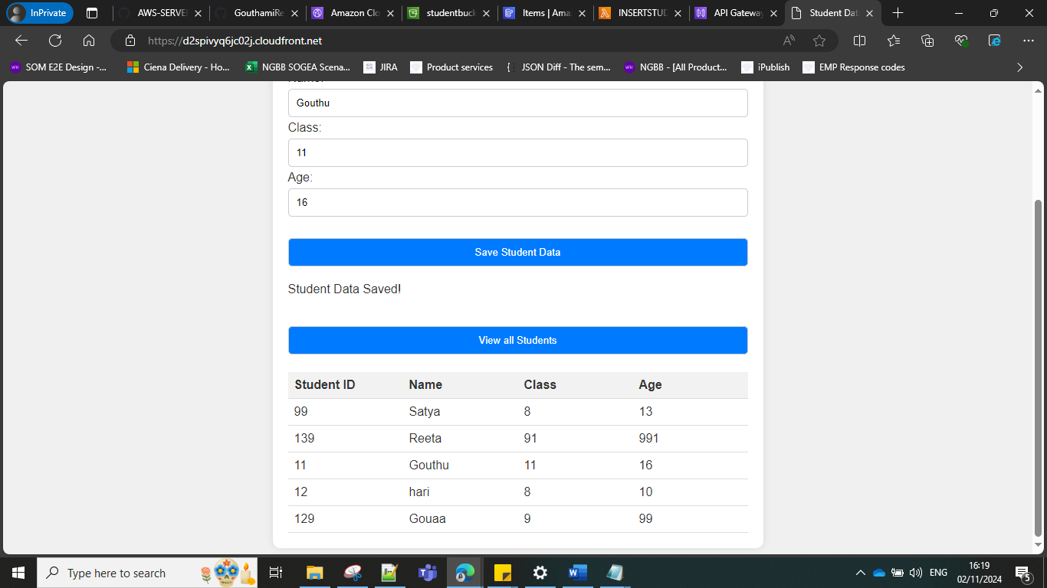

HURRAYYYY!!!!!!!!!!!!!!!!!!!!!!!!!!!!!!!!!!!!!!!!!!!!!!

